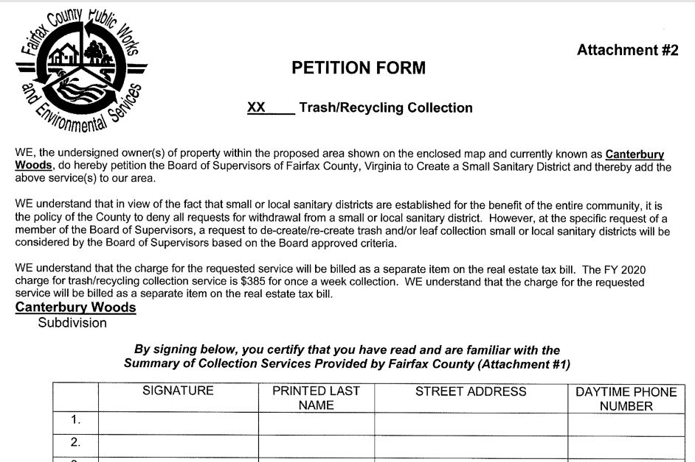
Petition #2
Trash/Recycling/Yard Waste and Vacuum Leaf
Petition #1
Trash/Recycling/Yard Waste Only Signature
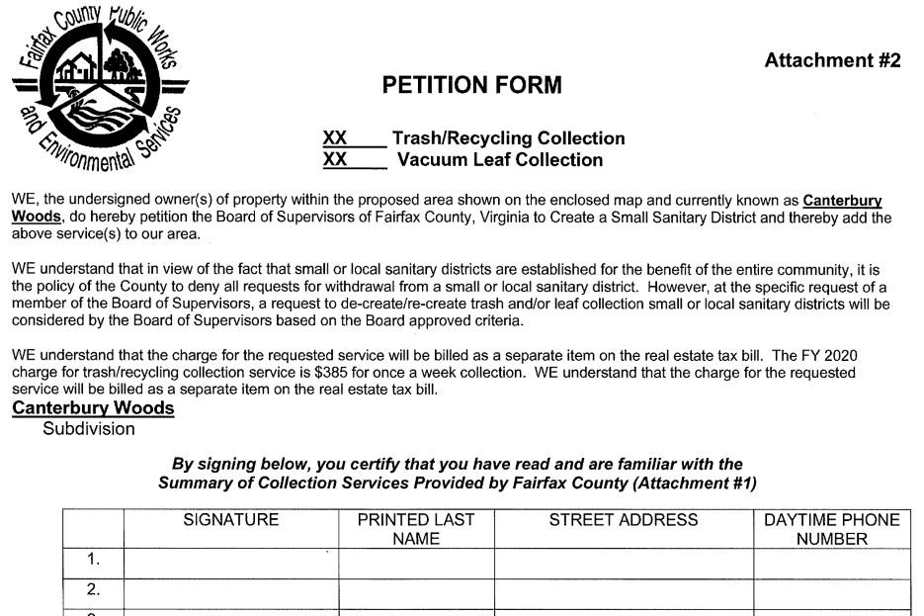
I HAVE BEEN CONTACTED AND DO NOT WISH TO SIGN EITHER PETITION

I DO NOT support the Trash Collection/Yard Waste petition or Vacuum Leaf Petition
 | Signature | Printed Last Name | Street Address | Phone #
1
2

I am not the Owner of the property, please contact the owners at:
Name:_______________________________ Phone: _______________ email: _________________________

